Do the following things to remotely access Raspberry Pi from your laptop

1. Turn on your WiFi mobile hotspot in your PC
2. Rename your SSID as **TANVEER PhD CoE**
3. Set Password as **r221b816**
4. Connect the type-C cable to Raspberry Pi
5. Wait for few minutes to boot the OS in raspberry pi
6. check your Wi-Fi hotspot connected device list at the beginning it is empty

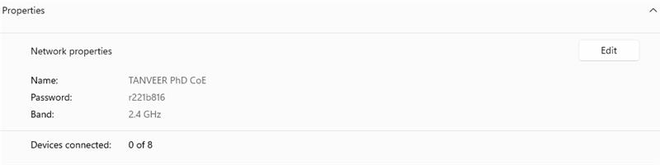

7. Check your Wi-Fi hotspot connected device list at the beginning it is empty

8. When the raspberry pi gets an IP from your PC through DHCP it will be on the device list

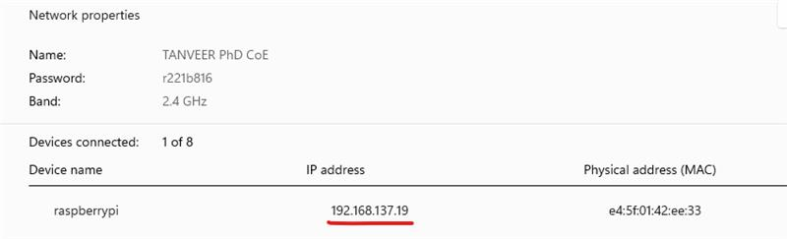

9. Now, we would like to access the raspberry pi using PuTTY through SSH

10. Download the PuTTY and open this



11. In PuTTY write the IP address of the raspberry pi in this case my raspberry pi gets **192.168.137.19**

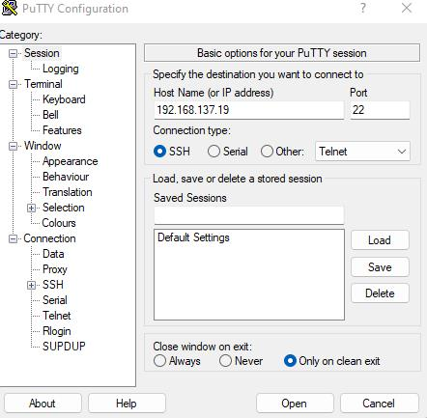

12. Click Open. it will open a terminal window. In terminal window login using username (**tanveer**) and password (**1234**)

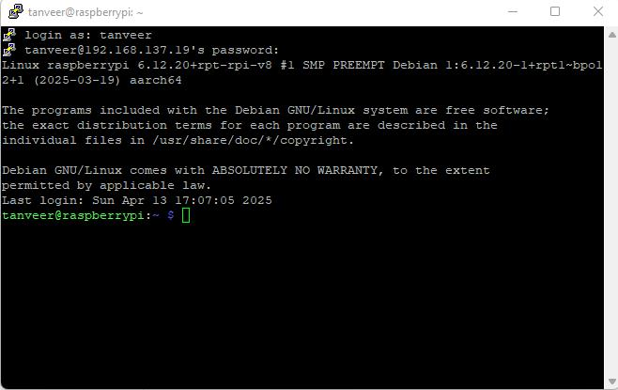

13. Now you get the access to raspberry pi OS.

14. You can remotely access raspberry Pi as like windows in remote desktop connection through VNC viewer.

15. In the terminal do this command **sudo raspi-config**

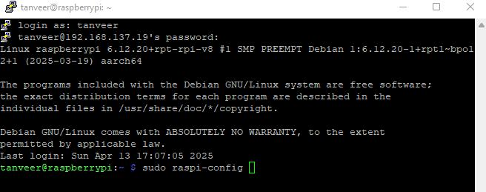

16. Select Interface options

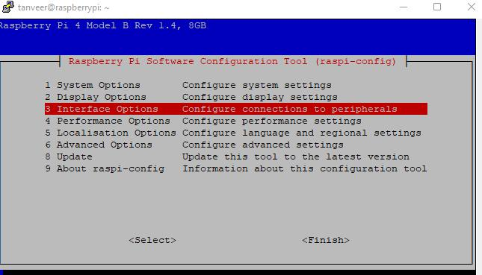

17. Select VNC

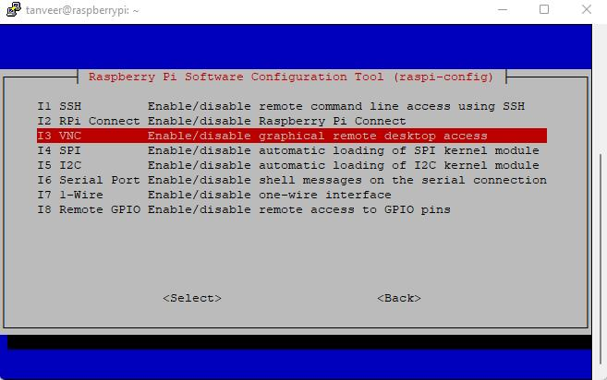

18. Enable VNC

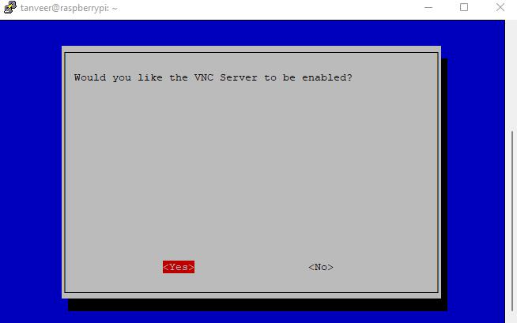

19. Now Download VNC viewer

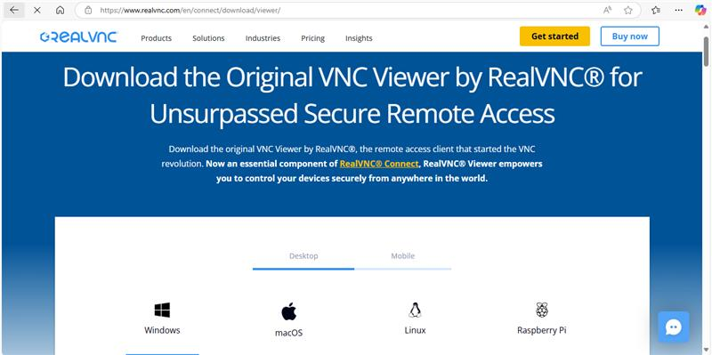

20. Open VNC viewer and provide your Raspberry Pi IP address 192.168.137.19 and username and password to connect

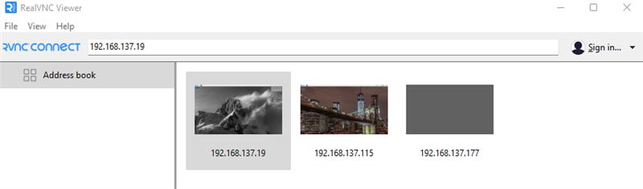

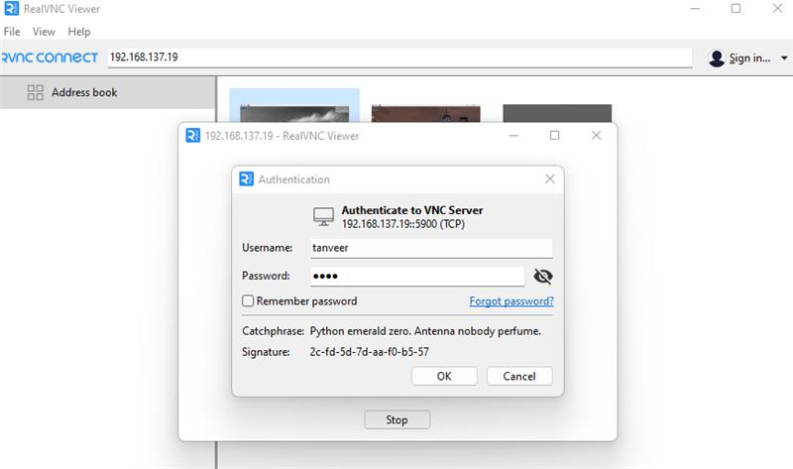

21. Now you can see your Raspberry Pi as like windows remote desktop.

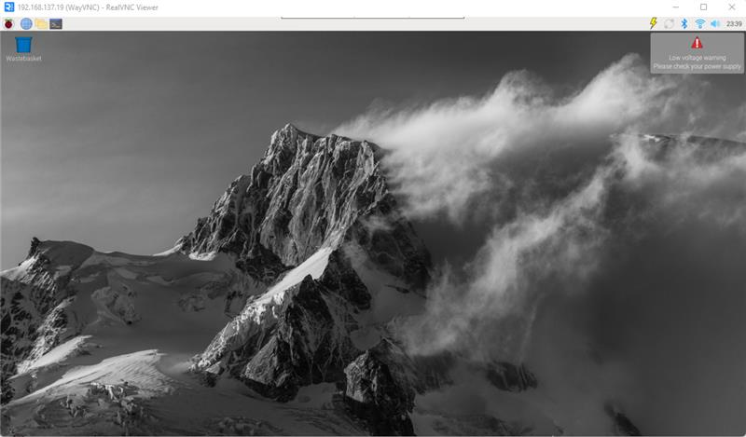

22. Now you can do what things necessary to do. I open the terminal and check my IP address.

